

COMSATS UNIVERSITY ISLAMABAD, ABBOTTABAD CAMPUS

DEPARTMENT: SOFTWARE ENGINEERING (BSE).

SUBJECT: OO SOFTWARE ENGINEERING.

SECTION: 4D.

SUBMITTED TO: SIR JAWAD KHAN.

SUBMITTED BY:

|  |  |  |
| --- | --- | --- |
| SERIAL NO. | NAME | REGISTRATION NUMBER |
| 01. | MARIA MANZOOR | FA20-BSE-161 |
| 02. | ZAKIR FAYYAZ | FA20-BSE-166 |
| 03. | RIZWAN SHAH | FA20-BSE-167 |

Book Appointment:

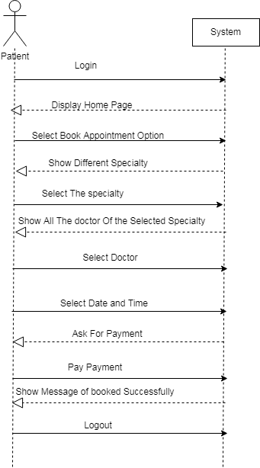

Book lab test:

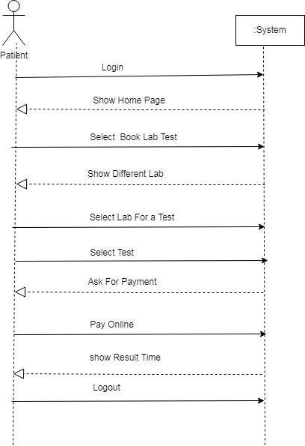

Order medicine:

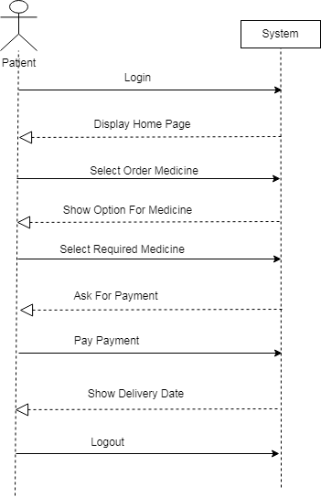

View lab report:

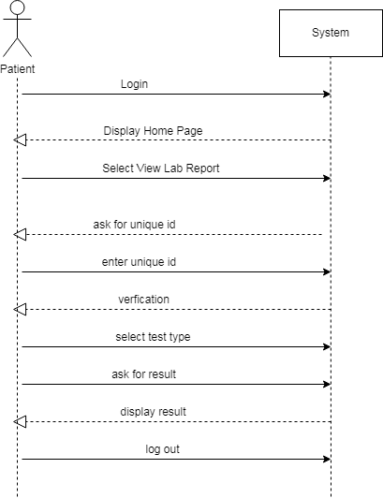

Check patient:

